**Ilminster Avenue Nursery School**

“Igniting Children’s Passions Through Play”

**April Newsletter 2024– Term 5**

**Welcome to Term 5!**

I literally can’t believe how fast this year is flying by! It’s been lovely to see little sunshine already this term.

We are planning yet another fun packed term. We will be growing seeds, watching caterpillars grow, finding out how to make our own play dough and learning rhymes.

We have been able to purchase some lovely new cascade water tables, so if you have any large plastic yoghurt pots so the children can use them in water play, please bring them in for us. Thank you!

**Mandy, Acting Head teacher**

**Staffing Updates**

As the Parents/Carers in Star room know, the class teacher, Sarah has been off for a while. She is now fully recovered and has started her phased return. This will be over the next 4 weeks until she will back with us full-time. Kari will remain in Star room through this transition period. I am sure you will join with me in thanking Kari for all her amazing hard work!

Jessy Woodman will be starting in Raindrops at the beginning of May. She is joining us on a permanent contract to replace Lisa Banger. We are excited to welcome her!

We have also taken on Izzy Warren as bank staff. This means Izzy may work in any room to cover staff absences.

**Oral Health**

As part of our Early Years curriculum, it is important that we focus on the importance of looking after our teeth. During term 3, as part of “Making Healthy Snacks”, the children explored cleaning their teeth.

Even though the children are still so young it is important to try and sign them up to your local dentist and start good habits of visiting and having check-ups.

We also ask that the drink bottles that children bring to school should have water in them. If your child struggles to drink water, only add very watered-down squash to help protect their teeth. There are also some leaflets in Rection on top tips on swapping sugary treats for healthy alternatives.

**Family Link**

Thanks to everyone who was able to make it to the “Coffee and Chat” session. Lucy is looking forwards to making this a regular termly session and welcoming more of you. The aim is to hear the things that you would like to talk about and plan sessions around this. Lucy would like to make this “your” group and provide chats and support around your key interests. If you have any ideas for the next one, please see Lucy so that she can start to plan it.

**Lucy Hobbs, Family Link Worker**

**Drop Offs and Pick-Ups**

Unless specifically agreed with your child’s key worker, children should be dropped off at 9am: Mon, Tues, Thurs and Fri and 8.45am on Wednesdays. We understand that sometimes you may be a little late, so we keep the gate open until 9.15am. Collection is at 3pm every day (11.45am for M-W children). **If** **you need to collect before this, we need you to come at 2.30pm**. Exceptions will need to be booked in with the admin team. This will really help the team to complete their other work. Children will need to be signed in and out if they arrive/leave outside of our set hours. Thank you.

**Dates for Your Diary**

Monday 6th May: Bank Holiday

Friday 24th May: Term ends

Monday 3rd June: Term 6 begins.

Wednesday 10th July: Inset day

We are planning some transition work with eh primary school and will pass on these dates as soon as they have been decided.

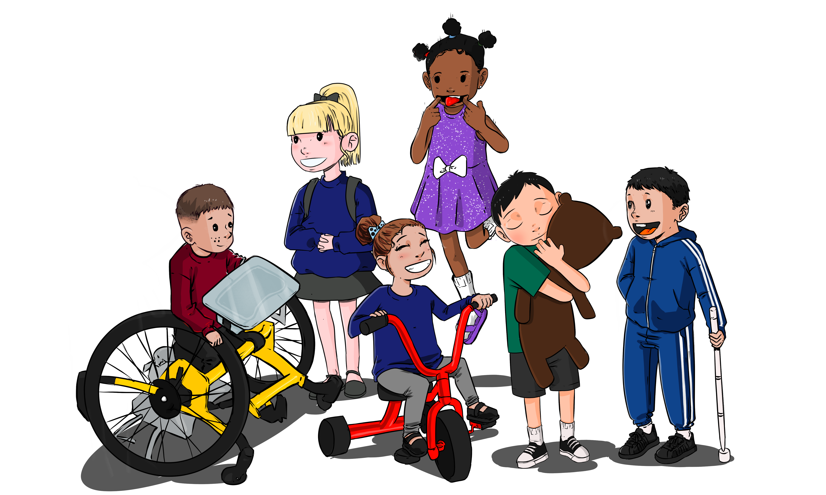

**“The beautiful thing about Learning is that no-one can take it away” BB King**

**Term 5 Curriculum**

**This term our Curriculum focus is “Making Play Dough**”. The children will be learning all the skills needed to be able to make their own play dough independently. The children will be exploring all areas of the curriculum through this focus:

**Personal, Social and Emotional Development:** The children will be learning to co-operate in groups, take turns and happily wait for their turn, follow the rules of a simple recipe and use talk to solve their own problems.

**Language Development**: Be able to talk about stories, being aware of story structure and the main characters, listen and respond to friends, follow and recall simple instructions. They will be learning vocabulary to join sentences together e.g. and, next, because.

**Physical Development**: developing skills to make controlled marks with pens etc, , chose how to move, using words to describe movements e.g. running, walking, crawling, creeping. They will develop skills to use scissors with more accuracy.

**Maths**: Continuing to explore “subitising” skills. They will notice groups up to 5 and be able to share a set of objects between a small group of friends. They will be able to begin to explore “5-frames” to help them organise groups of objects. They will use “subitising” vocabulary and sequencing words.

**Literacy**: Exploring rhyme and making their own rhymes, using their names. They will develop mark making to start to write letter like shapes and some letters from their names.

**Expressive Art and Design:** Using sounds and instruments to represent characters from stories, using rhyme in songs, explore colour and how to sue it in their own creative work.

**Understanding of the World**: Plant seeds and explore life cycles. We hope to watch caterpillars turn into butterflies. They will learn vocabulary linked to growing plants: grow, stem, leaf, roots etc.

We have leaflets for Core Books and the curriculum for this term, to help you to support your child’s learning at home this term. A simple play dough recipe will come home towards the end of this term. Ask your child to show you how to make dough and explore playing with it together. Explore making Most importantly, have fun together! You will find the leaflets in the school entrance, in the leaflet rack by the desk.

**Sun Safety**

Although it is still really chilly, the sun is beginning to make an appearance. Please be aware of sun safety, children can burn even when its chilly. As soon as it starts getting a little warmer, children will begin to need sun cream applied before they come to Nursery and start to bring sun hats. Thank you.