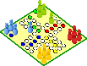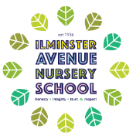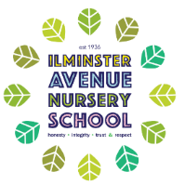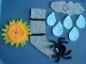 **Ilminster Avenue Nursery School**

**Explore Play dough**

* Can use different equipment with purpose e.g. roll with a rolling pin, make a shape with a cutter, brushes for sweeping
* Pouring, mixing and combining.
* Make large marks on paper with different mark making resources.
* Can run around and change direction, avoiding large obstacles.

**Vocabulary:** mixing, pouring, cutting, filling, squeezing, equipment t names

**Physical Development for Two Year Olds**

Physical activity is vital in children’s all-round development, enabling them to pursue happy healthy and active lives. It is crucial that we support children to develop their independence, core strength, stability, balance, spatial awareness, co-ordination and agility. Developing both their gross and Fine motor skills will enable them to develop control.

We want children to be able to run safely and confidently, climb over simple obstacles, make marks and develop independent self-help skills. We want them to try healthy and unfamiliar foods and begin to develop an awareness of the importance of oral health.

**Play a Game**

* Practise skills in running, changing direction and avoiding obstacles.
* Use mops and brushes to develop large mark making skills.
* Begins to develop skills to catch a large ball.
* Name different parts of their body.
* Make lines and marks with chalk, paint and pens.

**Vocabulary:** run, stop, catch, body parts, tired, thirsty

**Being happy at Nursery**

* Explore large movements, waving, kicking, jumping, climb over an obstacle
* Use sponges/cloths to squeeze, squash and throw.
* Using large movements to make marks.
* Use a spoon or fork to feed self.

**Vocabulary**: verbs, throwing, kicking, jumping, climbing, spoon/fork, name familiar resources.

**Explore Healthy Foods**

* Can use a spoon or fork to feed themselves.
* Explore using tools such as child friendly knives with adult support.
* Pour from jugs and cups with increasing control.
* Try different foods, textures and tastes.
* Wash hands with increasing independence.

**Vocabulary:** spoon, fork, cutting, mixing, pouring, words to describe taste and texture.

**Explore Nursery Rhymes**

* Begin to join in large movements when dancing.
* Walks upstairs with adult support, both feet on single step at a time.
* Attempts to use tools to interact with materials

**Vocabulary:** verbs, walking, climbing, cutting, mixing, name familiar resources.

**Contribute to Musical Experiences**

* Begin to engage with toilet training with support.
* Develop self-help skills: dressing and teeth brushing with some support.
* To move to music, waving ribbons and scarves.

**Vocabulary:** language to support toilet training, teeth, clean, dirty, toothbrush, names of clothing.