**Ilminster Avenue Nursery School**

“Igniting Children’s Passions Through Play”

**November Newsletter 2023– Term 2**

**Welcome to Term 2!**

I can’t believe that we are already in Term 2! I have really enjoyed getting to know you all last term.

Despite the dark nights, rain and cold weather, this term is always an exciting one in Nursery. Christmas will soon be upon us and glitter and sparkle will be everywhere!

We love Nursery and know that it is brilliant at supporting children with their learning and making progress. It is really important to try and bring your child every day! This time of year brings plenty of coughs and colds and when your child is poorly of course home is best. But the more they come to Nursery the more progress they make. We would love to see them all here as much as possible! It’s important that we know where the children are when they are not in school, so please ring us and let us know if they can’t be in that day. Thank you.

**Mandy Collier-King, Acting Head teacher**

**Governors**

Our Governing Body are a crucial part of our school. Have a look on our website if you would like to find out who they are. They act as a “critical friend” both supporting and challenging us to ensure we provide the best we possibly can for your children.

**We currently have a vacancy for a Parent governor.** If you are interested in this role, please come and talk to Mandy on the gate in the morning or end of the day.

Our Chair of Governors is called Marianne Croft. She can be contacted via the school office.

**Greeting Your Child**

One of our key pieces of work at nursery is to work alongside your child to help to develop their communication skills.

This year we have become a pilot school for a programme called Well Comm. Through individual observation and assessment, we are working out the next steps each child needs to make and using lots of fun activities to help them to make progress. We love working with the children to help them to share their thoughts, ideas and feelings.

We would love it if you could help too! So please talk to your children about their day, find out the things they have enjoyed doing at Nursery. If children find it tricky to share, perhaps give a couple of ideas. Build their confidence by being interested and praising all their attempts to share, even if they use 1 or 2 words. Have fun and enjoy this time together.

**Toilet Training**

The staff here at Ilminster Avenue are highly experienced in supporting children and families with toilet training. If you would like some support, please talk to a member of your child’s class team. They will be more than willing to work with you on this next important step. Children all get there in their own time, with the right support.

**Family Link**

Lucy is hoping to be able to run a Nurture group in January to support parents and families with all the challenges that parenting can bring.

We’ll keep you updated with any news of this.

In the meantime, Lucy’s door is always open. She works on Tuesdays, Wednesdays and Fridays. She is also in school on Thursdays but works in class with children on this day.

Please come and say hello to our newest member of staff: Charmaine has joined our fabulous admin team!

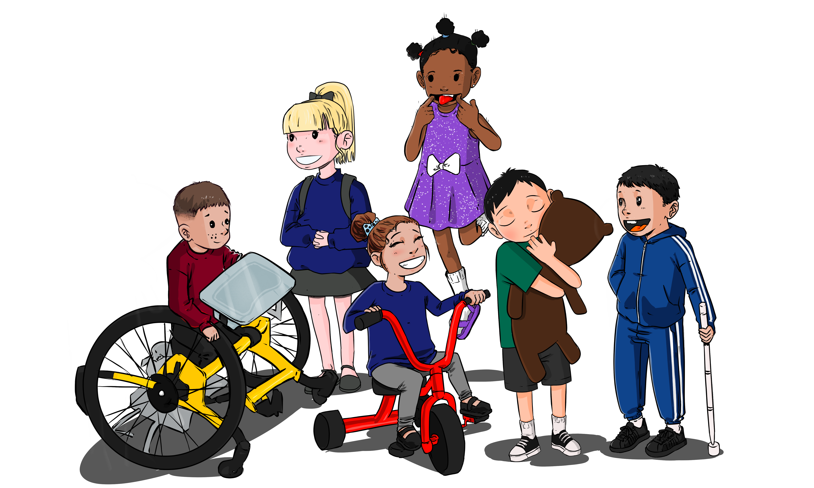

**Donations**

We would like to say **thank you** to Hannah-Jayne, one of our parents who completed a half marathon last term and raised a huge sum of money for our Nursery! We hope to use the money to buy a bubble tube for our Sensory Room.

**Dates for Your Diary**

**Fri 17th Nov**: Children in Need: wear spots and make a donation.

**Tues 21st and Thur. 23rd November:** Parent Engagement event: Spider making workshop.

**Thurs 7th Dec:** Christmas Jumper Day

**Tues 12th and Thurs 14th Dec :** Christmas Parties

**11th and 15th December**: Sun and Star Nativity performances

**15th December**: End of term

**Tues 2nd Jan:** INSET Day: School closed

**Wed 3rd January:** Start of Term 3

**“The beautiful thing about Learning is that no-one can take it away” BB King**

**Term 2 Curriculum**

**This term our Curriculum focus is “Learn a Nursery Rhyme**”. The children are all learning to remember and say “Incy Wincy Spider. They will be exploring this Nursery Rhyme in lots of different ways and learning the language from the rhyme e.g. “water spout”. The children will also be exploring all areas of the curriculum through this focus:

**Personal, Social and Emotional Development:** Exploring emotions and linking this to Nursery Rhyme characters.

**Language Development**: Learning new vocabulary linked to Nursery Rhymes, seasons and celebrations.

**Physical Development**: using one handed tools such as scissors, building on their self-help skills and using mops and brushes to make big movements that link to early writing skills.

**Maths**: Looking at patterns, noticing similarities and differences and sorting objects into 2 or 3 groups.

**Literacy**: Joining in with rhymes, making large marks, exploring different sounds musical instruments make.

**Expressive Art and Design:** clap along to a rhythm, making rhythms with tapping instruments, playing along with Nursery Rhymes.

**Understanding of the World**: use their senses to explore natural materials, talk about seasons and find mini beasts in the garden.

On Tuesday 21st and Thursday 23rd November at 2.15pm we would like to invite parents to join us for a spider making workshop. We will provide all the resources that you need to make a spider to take home with your child. You can then use the spider to help your child to retell the nursery rhyme or to play with the spider and act out “climbing up the water spout!” We would love to see you there!