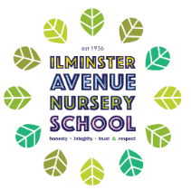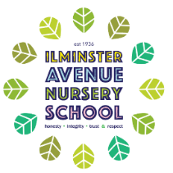 **Ilminster Avenue Nursery School**

**Contribute to Musical Experiences**

* Joins in with familiar songs.
* Begins to recall simple refrains.
* Responds to instructions and questions.
* Asks for help when they need it.

**Vocabulary:** help me, words from familiar songs, what, where, how

**Play a Game**

* Uses new words linked to turn taking and imaginative play.
* Beginning to listen to others, sometimes with adult support.
* Labelling and understanding the use of objects e.g. ball, dice etc.

**Vocabulary:** my turn, your turn, waiting, sharing, names of resources used in games.

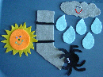

**Explore Healthy Foods**

* Begin to understand what objects are used for e.g. knives are for cutting.
* Begins to join in with familiar songs, singing repeated refrains.
* Likes to listen to share books and listen to stories with adults.
* Beginning to talk about themselves using “I, me, you”

**Vocabulary:** cooking utensils, I, me, you, word from familiar songs.

**Being happy at Nursery**

* Gestures to communicate, points to indicate wants/interests
* Beginning to use 1 or 2 word sentences
* Naming key resources and repeating words e.g. painting, drink, water, garden, raindrops.

**Vocabulary**: resources, key areas

**Explore Nursery Rhymes**

* Joins in some actions or take turns during singing familiar songs.
* Can understand simple instructions i.e. can find their coat/bag/drink.
* Copies familiar expressions, All gone, more please.

**Vocabulary: more, bag, drink, coat.**

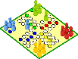

**Explore Playdough**

* Using new words with increased confidence e.g. utensil names
* Follow simple instructions with increased independence e.g. “roll the playdough”.
* Beginning to respond to simple questions.
* Use “me, I, you” to talk about themselves.

**Vocabulary:** Me, I you, what, where, how, names of utensils.

**Communication and Language for Two Year Olds**

We believe that developing children’s understanding of language and the skills needed to express themselves is the cornerstone of our curriculum.

Children communicate in many ways: using words, using signs and using visual picture cards.

Our approach is rigorous and robust.

We want children to: put words together, repeat words, learn new words, follow single word instructions, respond to familiar songs, be interested in books and story, to be able to stop and listen and use words like “me, I & you”.