**Ilminster Avenue Nursery School**

**June Newsletter 2023– Term 6**

**Welcome to Term 6!**

This year really has flown by! It’s been my first year at Ilminster Avenue Nursery School and I now feel completely at home! I have really loved working with all of our fabulous families and children!

We are planning a concert at the end of this term and hope you can all join us on Wednesday 19th July (details to follow). Bill has been working with Ilminster Avenue to bring musical experiences to the children for many years. This will sadly be his last year with us, so we want to share his work with you at our end of year celebration! We will also be exhibiting the family’s art work and planning to have a few stalls too to help raise a few pennies towards resources for the children.

This is the last term for some of our children, we wish them all the best as they begin to move to primary schools.

**Mandy, Acting Head teacher**

**Parent/ Carers Art project**

We are excited to continue to be involved in the “Story Telling” project with Bristol University and Luci Gorrell-Barnes, an experienced artist educator.

There will be two more workshops this term, Monday 12th June and Monday 19th June. Luci will be setting up in the “meeting place” at drop off and pick up times to entice you to contribute your stories. There will also be cakes to tempt you! Please come and share.

We will be displaying the art exhibition as part of our final celebration this year. You will all be invited to join us!

**Staffing Updates**

Sandy Maynard will be returning from maternity leave in the last week of this term. Sandy is a class teacher, returning to her role of job share teacher the second half of the week in Sun Room.

Becca, our Clerk to the Governing body, will also be returning from maternity leave at the beginning of July.

**Family Link**

We are planning to extend our two-year-old provision for September. If you know of any families that would qualify for a free two-year-old place, please share our name.

We will also be offering some paid places too. If you know of anyone in need of child care, again please share our contact details.

I am busy this term supporting families and children with their move to Primary school. If you have any worries or concerns regarding your child’s move, please come and see me.

**Lucy Hobbs, Family Link Worker**

**The Sandpit**

The observant amongst you will have noticed that the sand pit in the garden is currently closed. Unfortunately, it is in a bit of a sorry state at the moment. The wooden sleepers have degraded badly and we have had several incidents of children and staff getting splinters. We really don’t want any child to get hurt so we felt it would be best not to use it whilst we plan its improvement.

The good news is that there is a plan. Our site manager Gareth and Caretaker Jerry will be undertaking the re building of the wall around the sand pit. We are hoping that we will be able to complete this job before the end of term so that the children have a chance to enjoy it again before they leave.

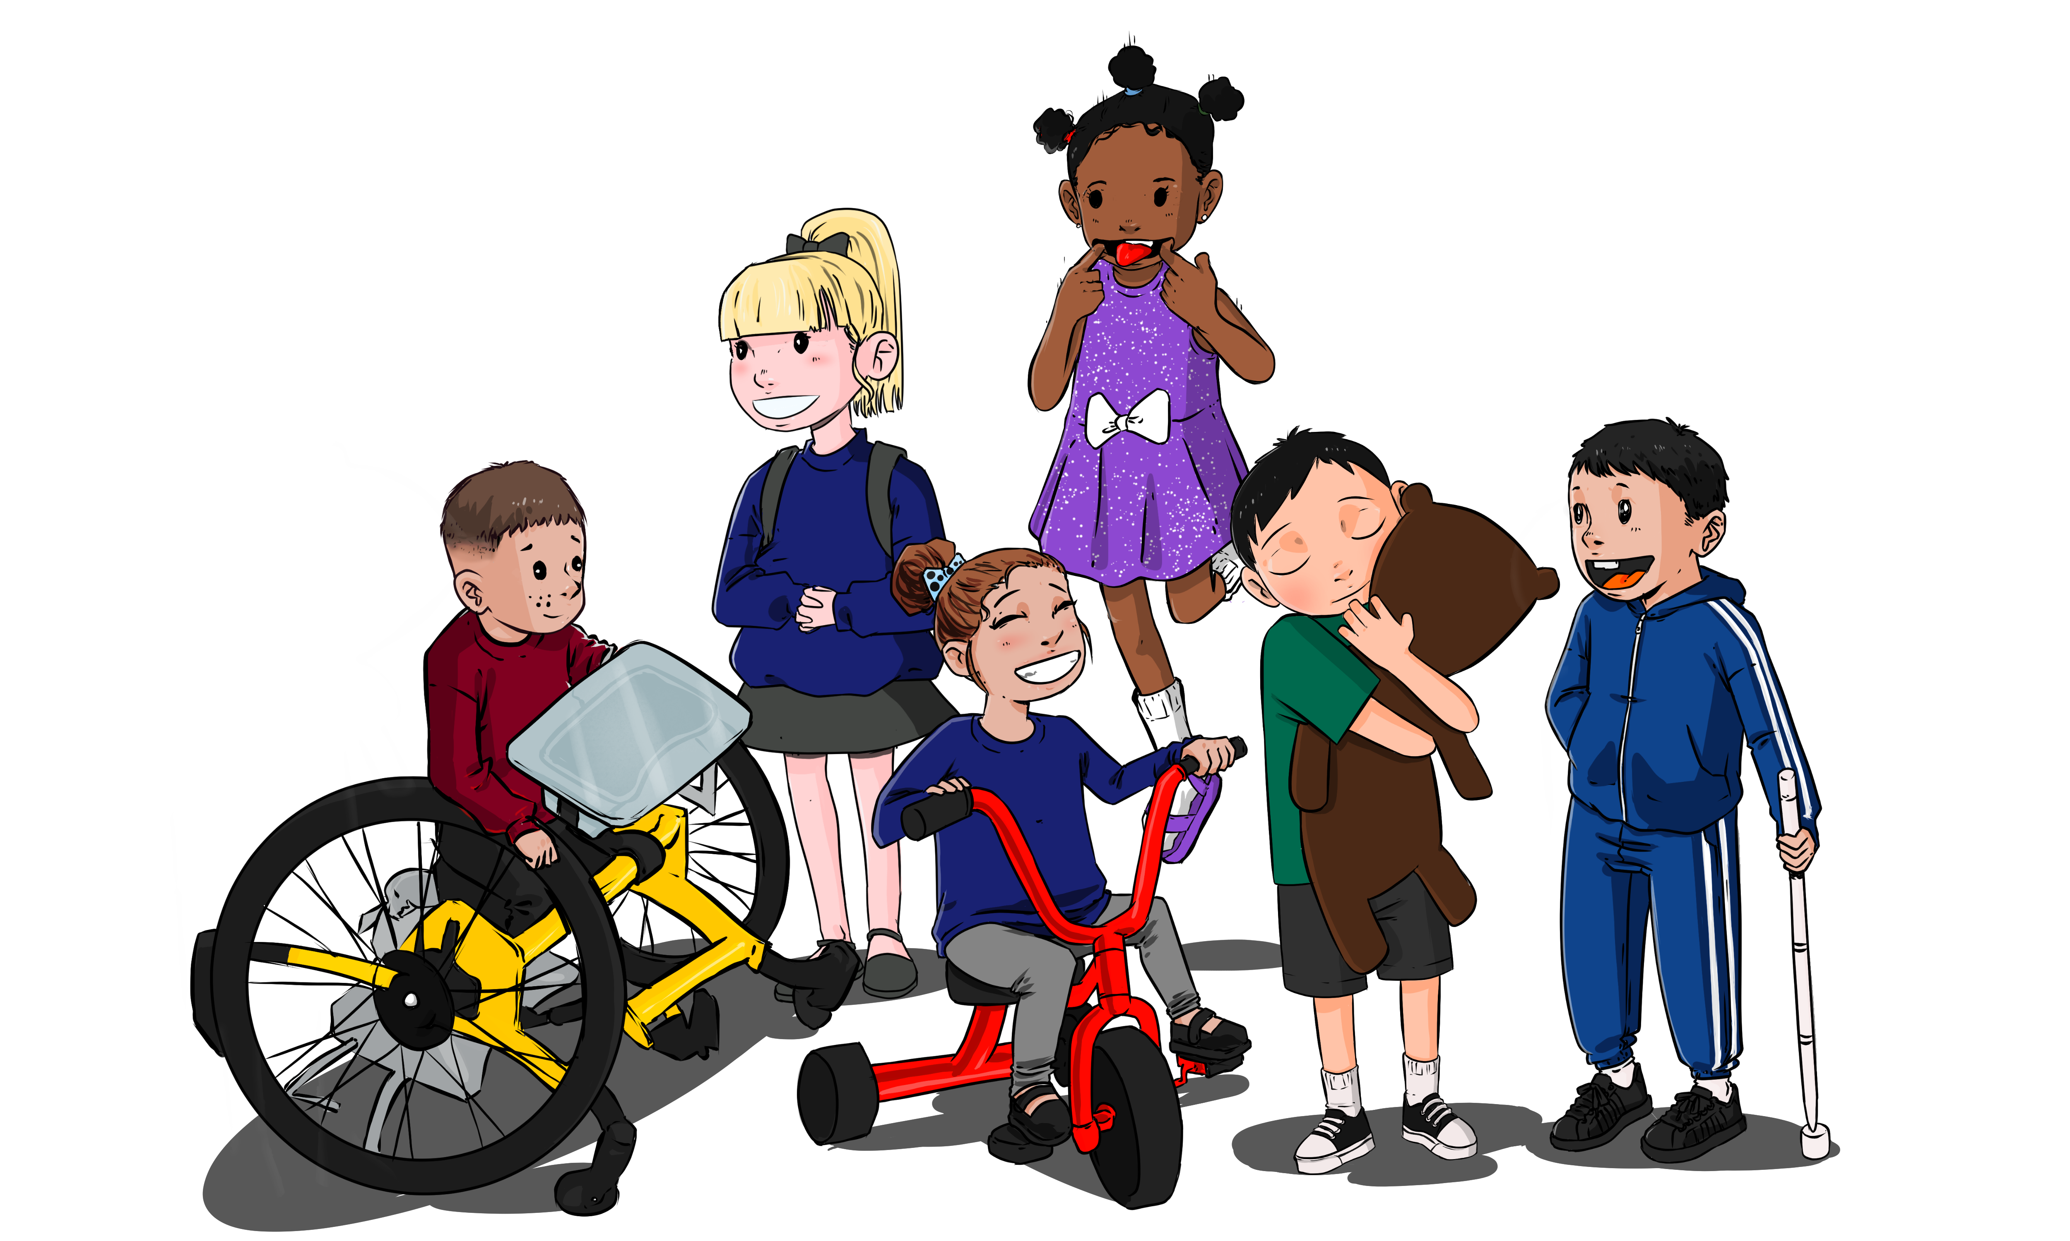

**Dates for Your Diary**

Monday 12th and 19th June: Family Art project

Wednesday 12th July: Inset day

Wednesday 19th July: Musical Performance

Friday 21st July: Term ends

**Term 6 Curriculum**

**This term our Curriculum focus is “Contribute to a Musical Performance**”. The children will be learning all the skills to be able to join in with our year end concert!

**Personal, Social and Emotional Development:** children will be developing their resilience and building up sustained engagement with an activity. They will explore setting themselves a goal and following it through and using these skills to help in their performance.

**Language Development**: Children will be encouraged to share their own ideas and talk about their thoughts. We will be encouraging children to have the confidence to ask questions as part of conversation. We want them to use their confidence to help them to take part in the performance.

**Physical Development**: We want children to begin to make controlled marks in their drawing and writing this term, as well as develop their scissor skills. We will also be encouraging children to solve their own problems e.g. asking a friend to help them with a tricky job such as moving a heavy tyre etc.

**Maths**: Children will be encouraged to solve everyday number problems e.g. how to share out resources with friends. They will continue to build up their subitising skills, using 5-frames.

**Literacy**: We will be supporting children to recognise some familiar letters and words, including their names. We want them to use familiar ideas to re tell stories and perform them. We will be encouraging children to make marks and letters to represent their names.

**Expressive Art and Design:** We will be working with xylophones and chime bars to make our own music. We may even explore the skills of “conducting” music and songs.

**Understanding of the World**: We will be exploring how things work and we will be thinking about the wider world, especially when we are looking forward to our holidays!

We are looking forward to putting all of our skills together to bring you Ilminster Avenue Nursery School’s end of year concert!

We are beginning to build up leaflets to help you to support your children’s learning at home too. We have leaflets on “Risky play”, “Play Dough”, “Messy Play” and “Open Ended play”. They are great for easy ideas over the long summer holidays. The leaflets can be found in our reception area, near the old -fashioned desk. Please come and help yourselves.

**Donations Welcomed!**

We would love empty containers that we can make out own musical instruments from. Please save any clean packets, boxes, empty plastic bottles for us. Bring them to the Reception are or pass to your child’s room leader. Thank you!