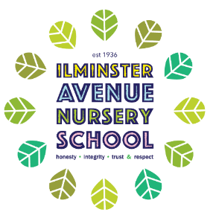

Core Book Approach at Ilminster Avenue Nursery School
At Ilminster Avenue Nursery School, our children will have experienced a variety of core books during their time with us. The books chosen underpin our sequential approach to providing the stepping stones to pre/early reading skills. The books also reflect our school community, providing the context to deliver appropriate and meaningful learning outcomes for our children.

Our Core Book approach enable children to make links and “layer” their learning across the curriculum. We believe this is the most effective way that young children learn.
Core Books will include:
- Traditional tales and Nursery Rhymes
- Books that promote a love of story through rhythm and rhyme
- Books that represent diversity and promote the representation of our community
- Stories that provide contextual learning for small groups and wider learning,
- Books that support critical thinking skills
- Stories that enhance early phonics skills (phase 1)
- Stories that use repetitive phrases to promote language development
- Stories that introduce new vocabulary

Two-Year Olds:
In the 2-year-old room, core books have been selected to encourage children to engage actively with the story. This includes books with “lift the flaps”, joining in with sounds, anticipation, repetition and those with “active” rhythms e.g. can be used to physically go on a journey.
These will be:
- Dear Zoo
- Walking through the jungle (Julie Lacome version)
- Brown Bear, Brown Bear
- Cock a Moo Moo
They will also have experienced “Talking Tunes” songs, action songs and Nursery rhymes regularly. This will provide children with a rich experience of language, vocabulary, rhythm and rhyme.
These books will always be available to children in the book areas. They are also used in larger group sessions. Singing stories are introduced where appropriate

Three-Year Olds:
Core books are used to provide the context for planned learning, promoting cross-curricular links. Staff will select core books according to the need of the class and the focus for learning. They will inspire planning for greater depth to support specific learning outcomes. The core books list for each stage are suggested. They are intended to represent the principles that underpin the pre reading skills process. A class teacher could choose a book not included on the core book list as long as it meets the defined learning outcomes for the appropriate stage in learning.

It is important to recognise that, although we have identified 6 stages, the core books have been set out in sequential steps, rather than in specific school terms. We recognise that children learn at different paces and children join the class at different times throughout the year. A single core book can be used to meet a variety of learning needs.

Stage 1: Books that promote fun and enjoyment. Stories that encourage joining in with sounds. Stories that have simple text that uses rhythm. Stories that clearly focus on the use of simple verbs e.g. walking.
These books will be available in book boxes and shared with children regularly as part of the free flow, in small groups and in larger groups. It is assumed that this is the stage when children are settling into new rooms and need to build relationships with adults and feel happy and settled in their new environment. There will be some overlap with the books used with the “two’s” to support transition and embed learning.

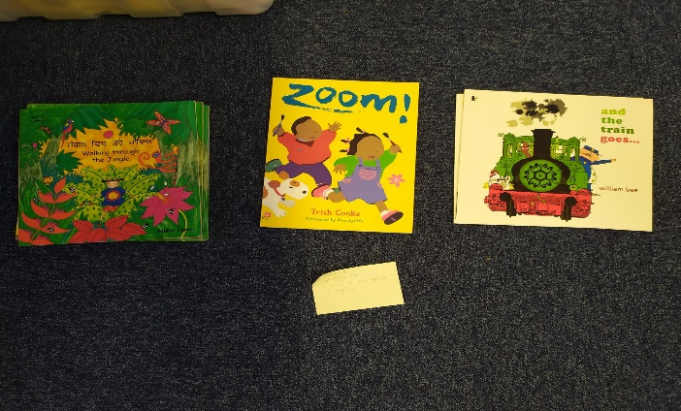

Stage 2: Nursery rhymes and stories with a simple but clear story structure, repeated refrains or structured phrases that repeat throughout. This will help to build memory of text and recall.
These will be used for curriculum planning, making links throughout the curriculum. There will be an emphasis on vocabulary, looking closely at new and unfamiliar words e.g. words such as “tuffet” in “Little Miss Muffet”.
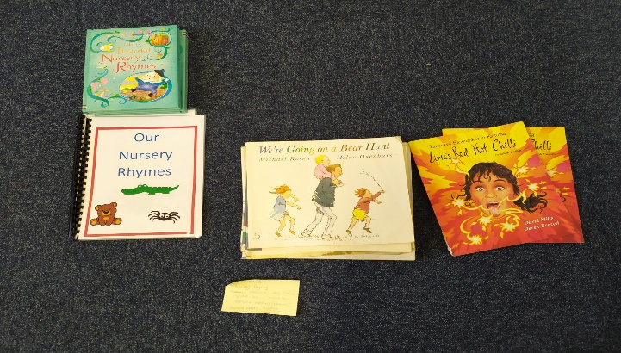

Stage 3: Traditional tales with focus on story structure and retelling of stories. Enabling children to play at retelling stories. Stories with repeated refrains to support recall and building memory of story language and story vocabulary.
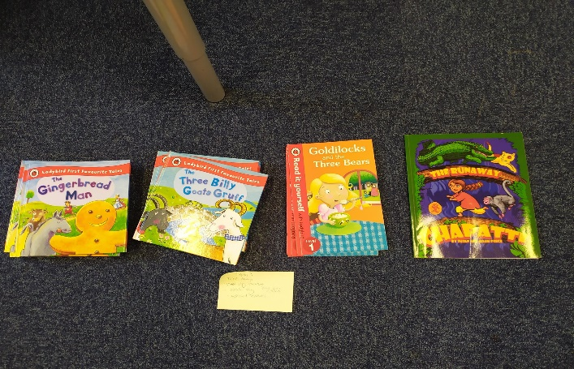

Stage 4: Stories that introduce problem-solving ideas. Stories that encourage children to make predictions and anticipate what might come next. Stories that encourage children to sequence event and recall this sequence. Building on and developing story language vocabulary e.g. Once Upon a time.
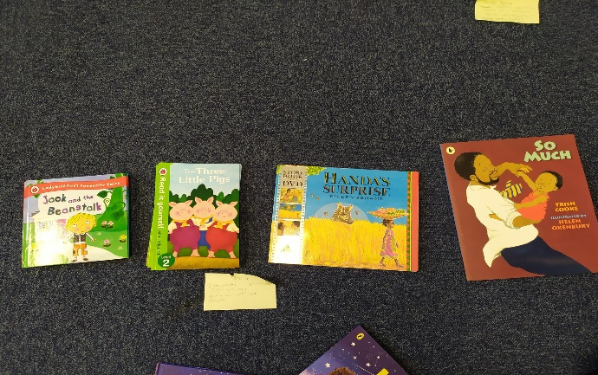

Stage 5: Stories that focus on rhyming, encouraging children to see the rhyme to guess the final word or to begin to play with creating their own rhymes. Encouraging children to summarise stories, showing they can recall events. Building on making predictions about the end of the story. children will be given opportunity to tell their own stories, encouraging story structure and story vocabulary.
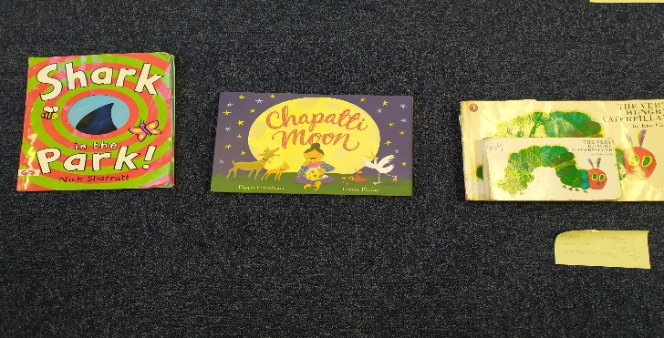

Stage 6: Stories that contain a focus on phonics and rhymes. Also introducing stories that extend narrative and continue to introduce new vocabulary. Encouraging children to listen to and enjoy longer stories.
