**Ilminster Avenue Nursery School**

**April Newsletter 2023– Term 5**

**Welcome to Term 5!** I literally can’t believe how fast this year is flying by!

Let’s hope that the weather cheers up soon and brings some sunshine. Things are always better in the sun!

We are planning yet another fun packed term. We will be growing seeds, watching caterpillars grow, celebrating the King’s Coronation, planting in our allotment boxes, exploring food, creating music and launching the Families art project!

The term will also feel slightly shorter with 2 bank holidays and 2 planned NEU strike days. The disruptions are unfortunate but the strikes are not just about teacher pay. They are also about the lack of funding that all school but especially Nursery Schools are facing. The children deserve the best education we can offer!

**Mandy, Acting Head teacher**

**Parent/ Carers Art project**

We are excited to be involved in a “Story Telling” project with Bristol University. Luci Gorrell-Barnes, an experienced artist educator is joining us to help members of our school community to reflect on and tell their stories and personal experiences of the pandemic. Luci will be available on the gate on Friday 28th April if you have any questions.

The workshops will take place over three weeks. We really hope that you will be interested and want to join in. Lucy Hobbs is involved in the project and encouraging you to join in!

**Staffing Updates**

Mandi who worked in the office has now moved on and Danielle has returned from Maternity leave. We are sorry to see Mandi go but are very excited to have Dan back. Many of you may already know Dan. If you haven’t met her yet, pop into the office to say hi!.

We have a 2.5 day vacancy in Sun Room. If you, or anyone you know has a child care qualification and is interested in the position, please come and see me.

**Family Link**

Thanks to everyone who was able to make it to the toilet training. If you were unable to make it or would like more information please come and see me in my room.

I will also be joining the art project in May and June. It would be great if you could come and join us. The project will help us to reflect on our experiences during the pandemic and a great opportunity to just talk! Come and see me if you would like to know more.

**Lucy Hobbs, Family Link Worker**

**The King’s Coronation Celebration**

Any excuse to have a celebration! We are going to mark the Coronation of King Charles by having a party on Wednesday May 3rd here at Nursery. Classes will be sending out invitations and letting you know how this will work for your child’s class.

Although our children are very young and may not have much awareness of this historic event, we feel it is really important to provide a “learning” experience that is meaningful for the children. We are really looking forward to it!

**Dates for Your Diary**

Thursday 27th April & Tuesday 2nd May: Strike days

Monday 1st May & Monday 8th May: Bank Holidays

Wednesday 3rd May: Coronation Celebration Party

Thursdays 4th,11th & 18th May: Family Art Project

Friday 26th May: Term ends

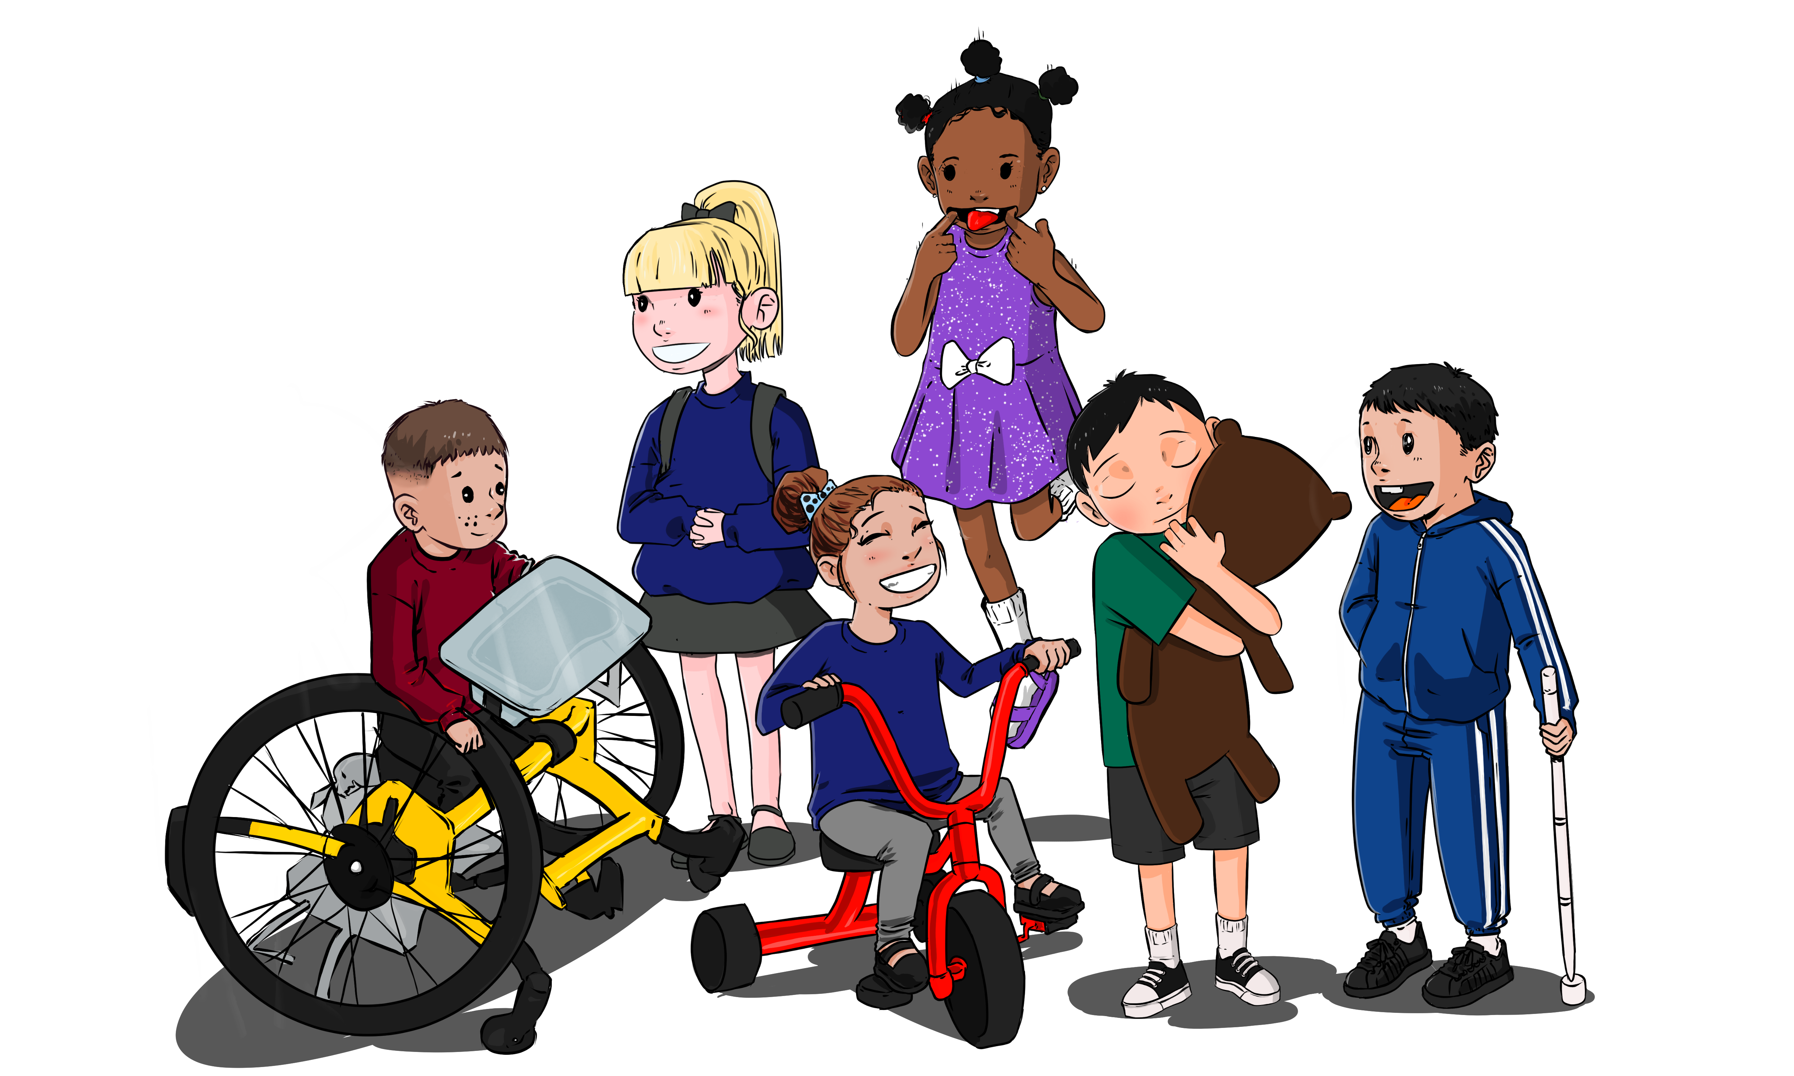

**Term 5 Curriculum**

**This term our Curriculum focus is “Play a Game**”. The children will be learning all the skills to play a variety of indoor and outdoor games. The children will be exploring all areas of the curriculum through this focus:

**Personal, Social and Emotional Development:** The children will be learning to co-operate in groups, take turns and happily wait for their turn, follow the rules of simple games and sue talk to solve their own problems.

**Language Development**: Be able to talk about stories, being aware of story structure and the main characters, listen and respond to friends whilst paying games, follow and recall simple instructions. They will be learning vocabulary to join sentences together e.g. and, next, because.

**Physical Development**: developing skills to make controlled marks with pens etc, chose how to move, using words to describe movements e.g. running, walking, crawling, creeping. They will develop skills to use scissors with more accuracy and join in with outdoor games.

**Maths**: Continuing to explore “subitising” skills. They will notice groups up to 5 and be able to share a set of objects between a small group of friends. They will be able to begin to explore “5-frames” to help them organise groups of objects. They will use “subitising” vocabulary and sequencing words.

**Literacy**: Exploring rhyme and making their own rhymes, using their names. They will develop mark making to start to write letter like shapes and some letters from their names.

**Expressive Art and Design:** Using sounds and instruments to represent characters from stories, using rhyme in songs, explore colour and how to sue it in their own creative work.

**Understanding of the World**: Plant seeds and explore life cycles. We hope to watch caterpillars turn into butterflies. They will learn vocabulary linked to growing plants: grow, stem, leaf, roots etc.

We will be sending home ideas for how you can support your child’s learning at home this term. It would be great if you could make time to play simple board games at home. Use language such as “my turn” “your turn” to help with turn taking, model counting using a dice; “I can see one, and another one and anther one…that’s a group of 3!”Encourage your child to tell you the rules of the game after you have played the same game a few times! Most importantly, have fun together!

**Donations Welcomed!**

We are looking for donations of beans to grow and Sunflower seeds. We would also love any left-over flower pots you may have, soil/compost and spoons for transporting the soil into pots!