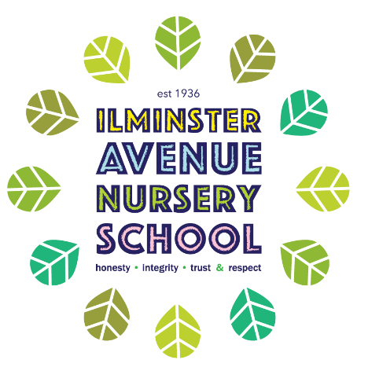

Sick Children and Medication Policy

Date | Tracked Changes
27.2.23 | Added: label must be on packaging and medication.  Non-medication section amended: Staff will not be expected to administer non prescribed medications.

Rationale
Children who have infectious illnesses, or who are feeling ill, should be cared for at home. However, we acknowledge that there are circumstances where children will become ill or feel unwell whilst attending the setting. We also acknowledge that some children need medication to be administered during the day.
Aims
- To promote the good health of children and to take appropriate action when they are ill.
- To prevent the spread of infection.
- To implement effective management systems to support individual children’s medical needs.
- To ensure the safe administration of medicines.
Guidelines
- The following procedures are adhered to following advice from the Department of Health, the Statutory Framework for the Early Years Foundation Stage, and Bristol City Council.
Children who are unwell:
- In order to prevent the spread of infection through the setting, children will not be admitted when presenting symptoms of illness.
- Parents/carers will be contacted if their child becomes sick during the day and they will be expected to make arrangements to have their child collected from the setting as soon as possible.
- Parents/carers will be asked to notify Ilminster Avenue Nursery School if their child is ill and the nature of the illness.
- If a child develops diarrhoea or vomiting they must remain at home until a clear 48 hours have passed with no presentation of these symptoms.
- If children are completing a course of antibiotics, they may return to nursery when symptoms have ceased. Children will not be admitted until they have been taking medication for at least 48 hours.
Medication:
- Medication should only be administered by staff following completion of the ‘Administration of Medication’ course.
- Staff can volunteer to take on this role and not directly instructed, unless this is specified prior to employment and included in the job description.
- Staff who undertake training are permitted to administer specific medication provided they have completed the relevant training, e.g. Buccalam.
- Further training will be provided by qualified health professionals in order to meet the long-term health/medical needs children. This training will be specific to the individual child.
- Medication will not normally be administered unless prescribed for that child by a doctor, dentist, nurse or pharmacist. It must be in its original container with the full pharmacy label. It must be prescribed for a current illness or ongoing condition and be within the expiry date. The label on the packaging must be the same as the one on the medication.
- The dosage and timing requested should match the instructions on the packaging.
- Parents must inform staff about the time of the child’s last dose and the amount and time of the dose to be given during the session.
- The child’s parent/legal carer must fully complete the Medication Consent Form in the presence of a member of Ilminster Avenue Nursery School providing signed consent.
- Parents/carers must accept responsibility for instructing staff.
- Each dose of medication will be checked against the parent’s/carer’s instructions and medication consent form, before being administered by a trained member of staff and witnessed by the child’s key person. This will be recorded and signed by both members of staff.
- The medication record must be signed by the parent/carer when they collect their child.
- If children require emergency medication, an individual protocol will be in place and parents will be informed immediately by telephone if it needs to be administered.
- Medication will be stored in a locked cabinet or cupboard, or refrigerated if necessary, out of the reach of children.

Non-prescribed medication

- Staff will not administer non prescribed medication such as Calpol. If a child requires Calpol they should generally be considered as too ill to attend Nursery.
- Nappy rash cream can be administered with written consent from the Parent/carer. Only the cream provided by the parents/carers can be used.

Policy date: January 2021 , reviewed March 2023.

