**Ilminster Avenue Nursery School**

**March Newsletter 2023– Term 4**

**Welcome to Term 4!**

This term always feels more hopeful as the spring flowers start to emerge and bring us a bit of colour. Let’s hope that it also starts to warm up a bit more too!

It’s fab watching the children make progress at this point in the year. They are becoming so confident and able to make explore new activities and opportunities independently. They have particularly enjoyed “making healthy snacks” last term. The children in Star and Sun made themselves healthy wraps, the Snowflakes and Raindrops children bravely touched, smelled and tasted raw and cooked vegetables and tasted smoothies.

They will be building on their new vocabulary and use of tools to explore mixing and combining different resources, exploring and making play dough this term .

Hope you all have a fabulous term 4!

**Mandy, Acting Head teacher**

**Parent/ Carers Art project**

We are excited to be involved in a “Story Telling” project with Bristol University. Luci Gorrell-Barnes, an experienced artist educator is joining us to help members of our school community to reflect on and tell their stories and personal experiences of the pandemic. Luci will be working with staff as well as parents/carers at Ilminster Nursery. Luci will be available towards the end of this term to meet you and explain more. The project will happen here at Ilminster in the conservatory, in Term 5. Please ask for more details if you are interested in being part of this.

**Staffing Updates**

Natalie Pring is leaving us on March 31st! Natalie has been with us at Ilminster for at least 15 years. She started with us as a lunch time supervisor but was so brilliant she was soon encouraged to apply to be a practitioner. Natalie has worked in different rooms but more recently has been supporting children in Snowflakes room. She will be greatly missed but we are so pleased that she is moving on to a new career with the Disability Social care team. We wish her all the best!

**Hot Meals Funding**

As some of you already know, we have received some funding to be able to provide free hot meals for children on Mondays and Fridays. The funding has come to us thanks to the work of Jo Ingleby and “The Children’s Kitchen”. We are starting small in Star Room to begin with and hope to have the capacity to provide meals for Sun Room too, going forwards. The children have enjoyed having tasters and some have now fully committed to having a hot lunch. If you are a parent from Star Room and wish to sign your child up to a hot meal, please sign up on the list outside Star Room. Thank you.

**Family Link**

Lucy will be working with our local health visitor, to deliver support with the process of toilet training. This will take place on Wednesday 15th March at 11am and 12.15pm in the conservatory. There will be some top tips and advice as well as a chance for you to ask questions and share experiences with everyone who attends. Please, please come if you can…..it will be a really helpful session!

We are also receiving food from “Fair Share” on Tuesdays to replenish our “IHOPE” food bank. This will included fresh fruit and veg too. Please come and help yourself.

**Dates for Your Diary**

Thursday 2nd March: Strike day

Wednesday 15th and Thursday 16th: Proposed Further Strike Days (not yet confirmed)

Wednesday 22nd March: Parent workshop

Friday 31st March: INSET Day

Friday 31st March: Term ends

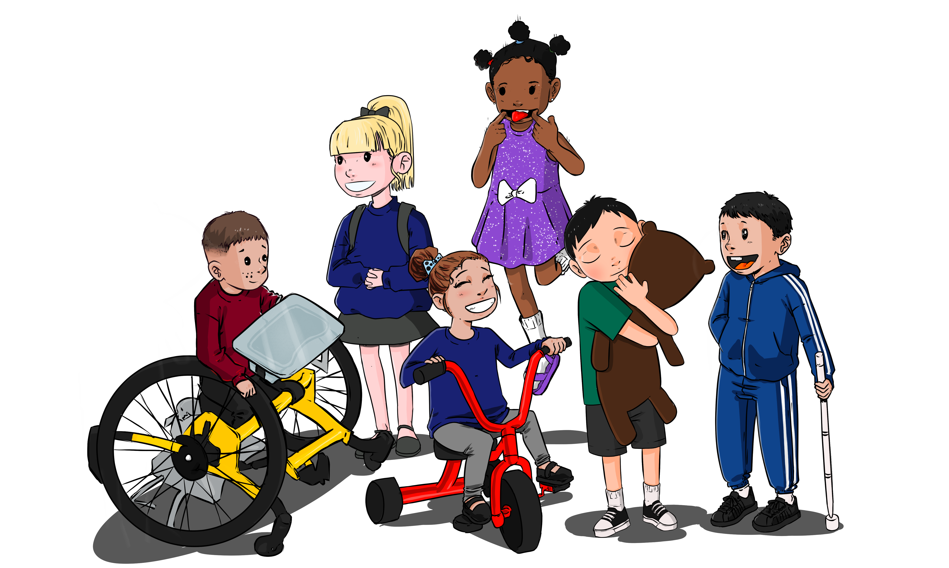

**Term 4 Curriculum**

**This term our Curriculum focus is “Make Play Dough**”. The children will be learning all the skills needed to make themselves their very own play dough. The children will be exploring all areas of the curriculum through this focus:

**Personal, Social and Emotional Development:** The children will be supported to become increasingly independent with solving their own conflicts and making independent decisions and choices.

**Language Development**: Building on the new vocabulary from last term as well as beginning to understand sequencing. They will be encouraged to talk about things that they remember and develop their listening skills in larger groups.

**Physical Development**: Building on their use of tools from last term, especially their scissor skills. They will be developing their wrist pivot to make controlled marks with chalk, paint and pens. They will be supported to draw figures that are becoming recognisable.

**Maths**: Continuing to explore “subitising” skills. They will notice groups up to 5 and be able to share a set of objects between a small group of friends. They will be able to follow a simple recipe to make playdough, counting the cups of ingredients for themselves with accuracy.

**Literacy**: Exploring rhyme and rhythm in familiar stories, especially traditional tales. “Reading” recipes and drawing recognisable figures.

**Expressive Art and Design:** Moving to different types of movement and talking about “happy” music “sad” music. They will be using play dough and clay to make different shapes and creations.

**Understanding of the World**: Exploring what happens when we combine and mix different things together. Explore the impact of different forces e.g. rolling, pressing, squashing and exploring other forces in the environment e.g. magnets, pedals on bikes, using ramps.

On Wednesday 22nd March we would like to invite parents to join us to make play dough. The workshops will be just before the time you collect your child at the end of their session: 11.30am and 2.45pm. We will provide all the resources that you need to make play dough with your child. You can have it to play at home too!

**Donations Welcomed!**

We are looking to add play opportunities to our outside area. We would love to replenish our “sand kitchen” so if you have any pre loved saucepans, plastic containers or utensils for mixing we would love to have them. This will help to support the children’s learning outside linked to our curriculum this term…..mixing and combing!