**Ilminster Avenue Nursery School**

**January newsletter Newsletter 2022– Term 3**

**Welcome to Term 3!**

Welcome back and Happy New Year! It is wonderful to see the children returning, full of tales of the things Santa brought them. We will also have new children joining us this term which means we are now virtually full across the school! It really will be a fantastically busy time ahead! As the children settle, your class leads may be making a few changes in response to our growing numbers, they will make sure you all have the information you need. We share information through Tapestry and the parent text messages. Please make sure you are able to access both of these. We also share lots about what the children have been doing in their classrooms via our face book page.

We have school sweatshirt available via the office for a cost of £10 each. If you would like one please come and see Mandi or Lian. We are also planning on re introducing “book share”. This is when children are able to borrow a book from school to share with you at home. We are hoping to have book wallets available soon to start this. The plan will be to ask for 50p towards the book wallets. This helps to keep the books safe and is a lovely link to when children later have a book bag at school. I hope you all have a fabulous Term 3.

**Mandy, Acting Head teacher**

**Governors**

We now have our full complement of Governors. We have two parent governors:

Mark Aldridge: parent of a child in Raindrops and in Sun Room.

Ariana’s dad: parent of a child in Star room.

Gavin Foreman is also a parent and will be a co-opted Governor. Gavin is a parent of a child in raindrops and a child in Star Room.

Parent Governors represent the voice of the parents at our school. If you would like to raise anything with a parent Governor, please do so. The governors may also activity seek the opinions of parents at points through the year.

**Welcome to New Staff**

We are welcoming new staff this term. We have Carly Mountford joining us in Snowflakes class, Carly Davey joining us in Star Room, Sherrie Foreman joining us in Sun room and Chelsea Derrick will be working in both Star and Sun rooms. Janina has moved from Snowflakes class into Star Room too. If you would like to be introduced please talk to the relevant staff in your child’s room. We are so pleased to have so many new faces join us.

**Family Link**

If you need support with your school place application please come and make an appointment with me this week and I can help you to complete and submit it.

I’m on the gate at the beginning and end of most days so please come and see me there if you need to make an appointment about school places or any other concerns you have.

I am always happy to hep!

**Primary School Applications**

If your child is going to be 4 years old before August 31st you will need to apply for a Primary School place for this September (2023). To do this you will need to go onto the Bristol City Council website and search for “School admissions”. You then need to complete the schools application. You need to put three preferences in the order of your preference. The closing date to apply is January 15th.

**Dates for Your Diary**

Monday 16th Jan: Schools application deadline

Wednesday 1st Feb: Parent workshop

Friday 10th February: Term Ends

Monday 20th February: Term 4 starts

Friday 31st March: INSET Day

Friday 31st March: Term ends

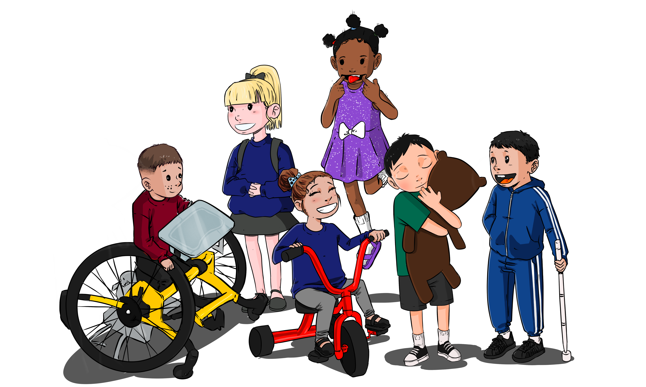

**Term 3 Curriculum**

**This term our Curriculum focus is “Make a healthy Snack**”. The children will be learning all the skills needed to make themselves a healthy snack, including developing their knowledge of what”healthy” means. The children will be exploring all areas of the curriculum through this focus:

**Personal, Social and Emotional Development:** Talking about what keeps us healthy. They will also be developing their resilience to keep trying even if a job is tricky. They will also be exploring finding solutions for everyday problems that arise within their session.

**Language Development**: Learning new vocabulary linked to being healthy, with a focus on verbs e.g. cutting, rolling, spreading etc.

**Physical Development**: using one handed tools such as child safe knives to chop and spread, as well as developing scissor skills to snip paper. They will explore keeping their bodies healthy, including cleaning teeth.

**Maths**: Beginning to explore “subitising” skills. This means noticing and describing a small number of objects without counting them (similar to the skill of recognising the dots on dice).

**Literacy**: Talking about the marks they make with pens and pencils, differentiating between sounds e.g. through body percussion and voice sounds and telling familiar stories through play.

**Expressive Art and Design:** Joining in with songs that use whole body movements, exploring body percussion and exploring mixing paints to make new colours.

**Understanding of the World**: Talk about the changes they notice in the environment e.g. freezing/melting. Notice and talk about changes in food preparation.

On Wednesday 1st February we would like to invite parents to join us to make a healthy snack. The workshops will be just before the time you collect your child at the end of their session: 11.30am and 2.45pm. We will provide all the resources that you need to make a healthy snack. We hope that you will have the opportunity to see the great skills the children are learning and how independent they are becoming nad perhaps include them in preparing foods at home.

**Donations Welcomed!**

We want to be able to provide children with a healthy snack of fruit and/or breadsticks every day but we need your help to do this! Please bring a donation of fruit in with your child to share with the class. The children will also be using snack times to practise their chopping and sharing skills. We would also be hugely appreciative of snacks such as breadsticks, crackers, wraps or pitta breads. Thank you so much!