**Ilminster Avenue Nursery School**

**November Newsletter 2022– Term 2**

**Welcome to Term 2!**

I can’t believe that we are already in Term 2! I have really enjoyed getting to know you all last term.

Despite the dark nights, rain and cold weather, this term is always an exciting one in Nursery. Christmas will soon be upon us and glitter and sparkle will be everywhere!

We also know that this term can be tough with all the coughs and colds that appear. Please can you ring the office if your child is unable to attend the Nursery that same day. This really helps us to know that the children are all safe and well with you. Although, Nursery is not statutory, it’s still really important that children come as much as they can and that we know where they are if they are unable to attend. Thank you.

We also know that this cost of living crisis will be tough as we move into winter. Please remember our IHOPE Food bank. We may also be able to help with a warm space if needed. **Mandy, Acting Head teacher**

**Governors**

We really need to recruit two Parent Governors to our school board. Please come and see me at the gate or speak to Mandi in the office if you are interested. The Governors meet 6 times a year on Mondays 4pm-6pm. We meet virtually so you can attend a meeting whilst staying at home! Being a Parent Governor is such an important role. Your voice as a member of the school community is very important and can influence the direction of the school. The Governors role is to be a critical friend to the school, asking questions and providing challenge in a constructive way. It is a really rewarding role. Please come and ask even if you feel you can only offer some limited time to the school.

Thank you.

Thanks you,

**Kate and Jo**

It is with great sadness that we will be saying goodbye to Kate Boyes (class teacher in Sun Room) and Jo Brunyee, practitioner in Star Room. Both have dedicated many years to Ilminster Avenue Nursery School.

Kate is choosing to retire after 35 years of teaching and Jo is pursuing a promotion in a Nursery in Southville.

I am sure you will join with us in thanking them for everything they have given to Ilminster and wishing them all the best in the future.

**Family Link**

Lucy will be introducing an information board for families to provide details of things going on in the community that may be of interest or supportive. The board will be in the foyer opposite Lucy’s room.

Keeping Bristol Safe Partnership has asked us to pass on that the Avon Fire and Rescue has developed an easy to use Home Fire Safety check. Search: <https://www.safelincs.co.uk/> to find the check list.

**Toilet Training**

The staff here at Ilminster Avenue are highly experienced in supporting children and families with toilet training. If you would like some support please talk to a member of your child’s class team. They will be more than willing to work with you on this next step. For children that may find this more challenging, we have information and strategies that could help.

**Dates for Your Diary**

Fri 18th Nov: Children in Need: wear spots or PJ’s and make a donation

Wed 23rd November: Curriculum workshop for Parents/Carers (see below for details)

Fri 9th December: Christmas Jumper Day

Wed 14th Dec: Class Nativity and singing

Tues 13th ad Thurs 15th Dec : Christmas Parties

16th December: End of term

Tues 3rd Jan: INSET Day: School closed

Wed 4th January: Start of Term 3

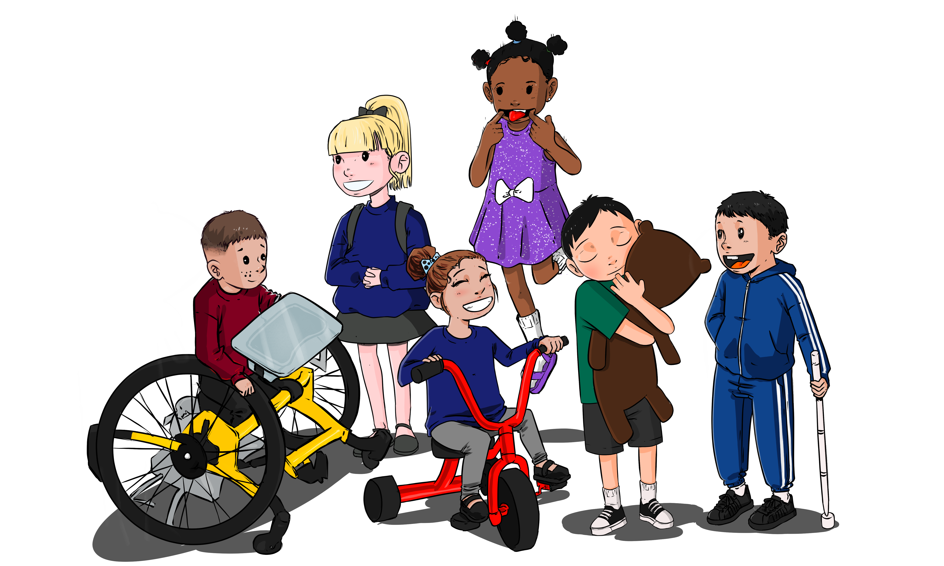

-

**Term 2 Curriculum**

**This term our Curriculum focus is “Learn a Nursery Rhyme**”. The children are all learning to remember and say “Incy Wincy Spider. They will be exploring this Nursery Rhyme in lots of different ways and learning the language inside the rhyme e.g. “water spout”. The children will be exploring all areas of the curriculum through this focus:

**Personal, Social and Emotional Development:** Exploring emotions and linking this to Nursery Rhyme characters.

**Language Development**: Learning new vocabulary linked to Nursery Rhymes, seasons and celebrations.

**Physical Development**: using one handed tools such as scissors, building on their self-help skills and using mops and brushes to make big movements that link to early writing skills.

**Maths**: Looking at patterns, noticing similarities and differences and sorting objects into 2 or 3 groups.

**Literacy**: Joining in with rhymes, making large marks, exploring different sounds musical instruments make.

**Expressive Art and Design:** clap along to a rhythm, making rhythms with tapping instruments, playing along with Nursery Rhymes.

**Understanding of the World**: use their senses to explore natural materials, talk about seasons and find mini beasts in the garden.

On Wednesday 23rd November we would like to invite parents to join us for a spider making workshop. The workshops will be when you bring your child at 9am or in the afternoon at collection time, at 2.45pm. We will provide all the resources that you need to make a spider to take home with your child. You can then use the spider to help your child to retell the nursery rhyme or to play with the spider and act out “climbing up the water spout!” We would love to see you there!

**End of Day Early Collections**

We are planning to change our early end of day collections slightly. We understand that some children need to be collected early as Primary Schools finish at a similar time but in order to help the team, we are going to ask you to “sign up” to pick your child up early. This way we can be prepared and a member of the class team will bring them down ready for you. The early collection time will be 2.30pm. We will send out a text as soon as this system is up and running.