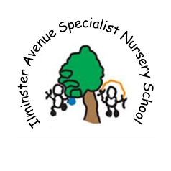

**Ilminster Avenue Specialist Nursery School**

**Newsletter**

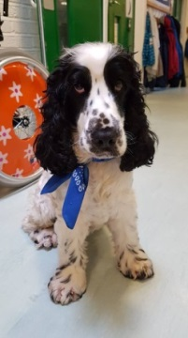

My name is Jake and I love coming into Ilminster

December2017 2017

What an exciting term we have had.

A new website up and running (ilminsterchildren.com), a visit from Pudsey Bear and a visit from Father Christmas.

Jake the dog has become a celebrity in his own right and really enjoys his new place of work along with his owner Matt Caldwell, Acting Head of the Mainstream Nursery. We have raised £87:80 from the raffle and £32 from reindeer food thank you all so much for your support.  
We come back on January 2nd but this is an inset day, so the children are due back in school on

**Wednesday** **January 3rd 2018**Don’t forget there is a Stay and Play Session  
 10:00am -1:00pm on Thursday 21st December

We wish you all a very happy holiday and look

forward to seeing you in January.

Matt and Trish

**Snowflakes room**

Snowflakes have been very busy joining raindrops for inclusion to practice their Christmas songs.

We are enjoying are Christmas activities and would like to wish all are children and families a very Merry Christmas and Happy New Year.

[](http://www.google.co.uk/url?sa=i&rct=j&q=&esrc=s&source=images&cd=&cad=rja&uact=8&ved=0ahUKEwimlczt6dDTAhXJtxoKHZgmBT8QjRwIBw&url=http://pngimg.com/img/nature/snowflakes&psig=AFQjCNGK44Od7wFcctcnAEiti_K_QHEV6w&ust=1493801357956926)

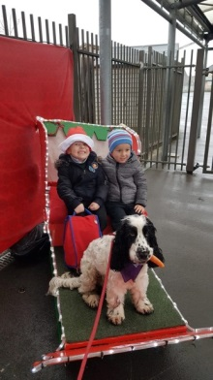

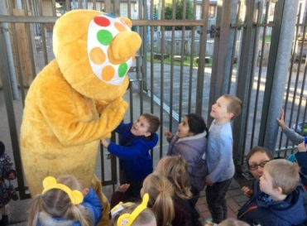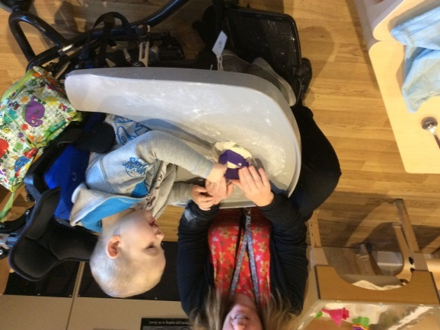

**Sun Room**

Sun group have been getting into the spirit of Christmas; the children have enjoyed listening to the Christmas story and a story about Santa being too noisy!  
They have taken part in creative activities such as sticking pieces together to make ‘Olaf’ as well as other things which will be a Christmas surprise for their families!

[](http://www.google.co.uk/url?sa=i&rct=j&q=&esrc=s&source=images&cd=&cad=rja&uact=8&ved=0ahUKEwjF3MOP7tDTAhWQZFAKHaIjAgAQjRwIBw&url=http://clipart-library.com/tear-cliparts.html&psig=AFQjCNEpeOuF2eeFlkgYl41B4R97WLYtWQ&ust=1493802497420915)

**Raindrops Room**

We would like to say goodbye to our friends that are moving into the over 3s building next term,   
we are certain they will enjoy their new adventure.   
We also look forward to welcoming lots of new children in January.   
We have had another great term with lots of messy play activities.   
Please remember to provide spare clothes as your children like to explore and sometimes get wet and messy.  
 We wish you all a Merry Christmas, and look forward to seeing you in the New Year.   
Merry Christmas from  
Marie, Louise, Marni, Hayley and Emily.

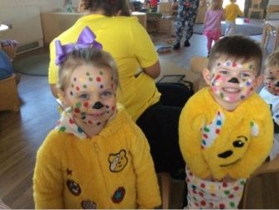

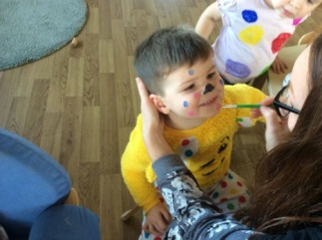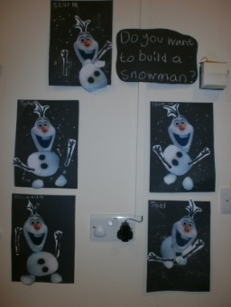



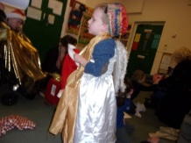[](http://www.google.co.uk/url?sa=i&rct=j&q=&esrc=s&source=images&cd=&cad=rja&uact=8&ved=0ahUKEwjF3MOP7tDTAhWQZFAKHaIjAgAQjRwIBw&url=http://clipart-library.com/tear-cliparts.html&psig=AFQjCNEpeOuF2eeFlkgYl41B4R97WLYtWQ&ust=1493802497420915)

**Star Room**

'There's great excitement and expectations for Class 5 children's Christmas performance with the parents and carers on Wednesday from 2... While we are trying our costumes a big baby arrived in our Nativity stable!'

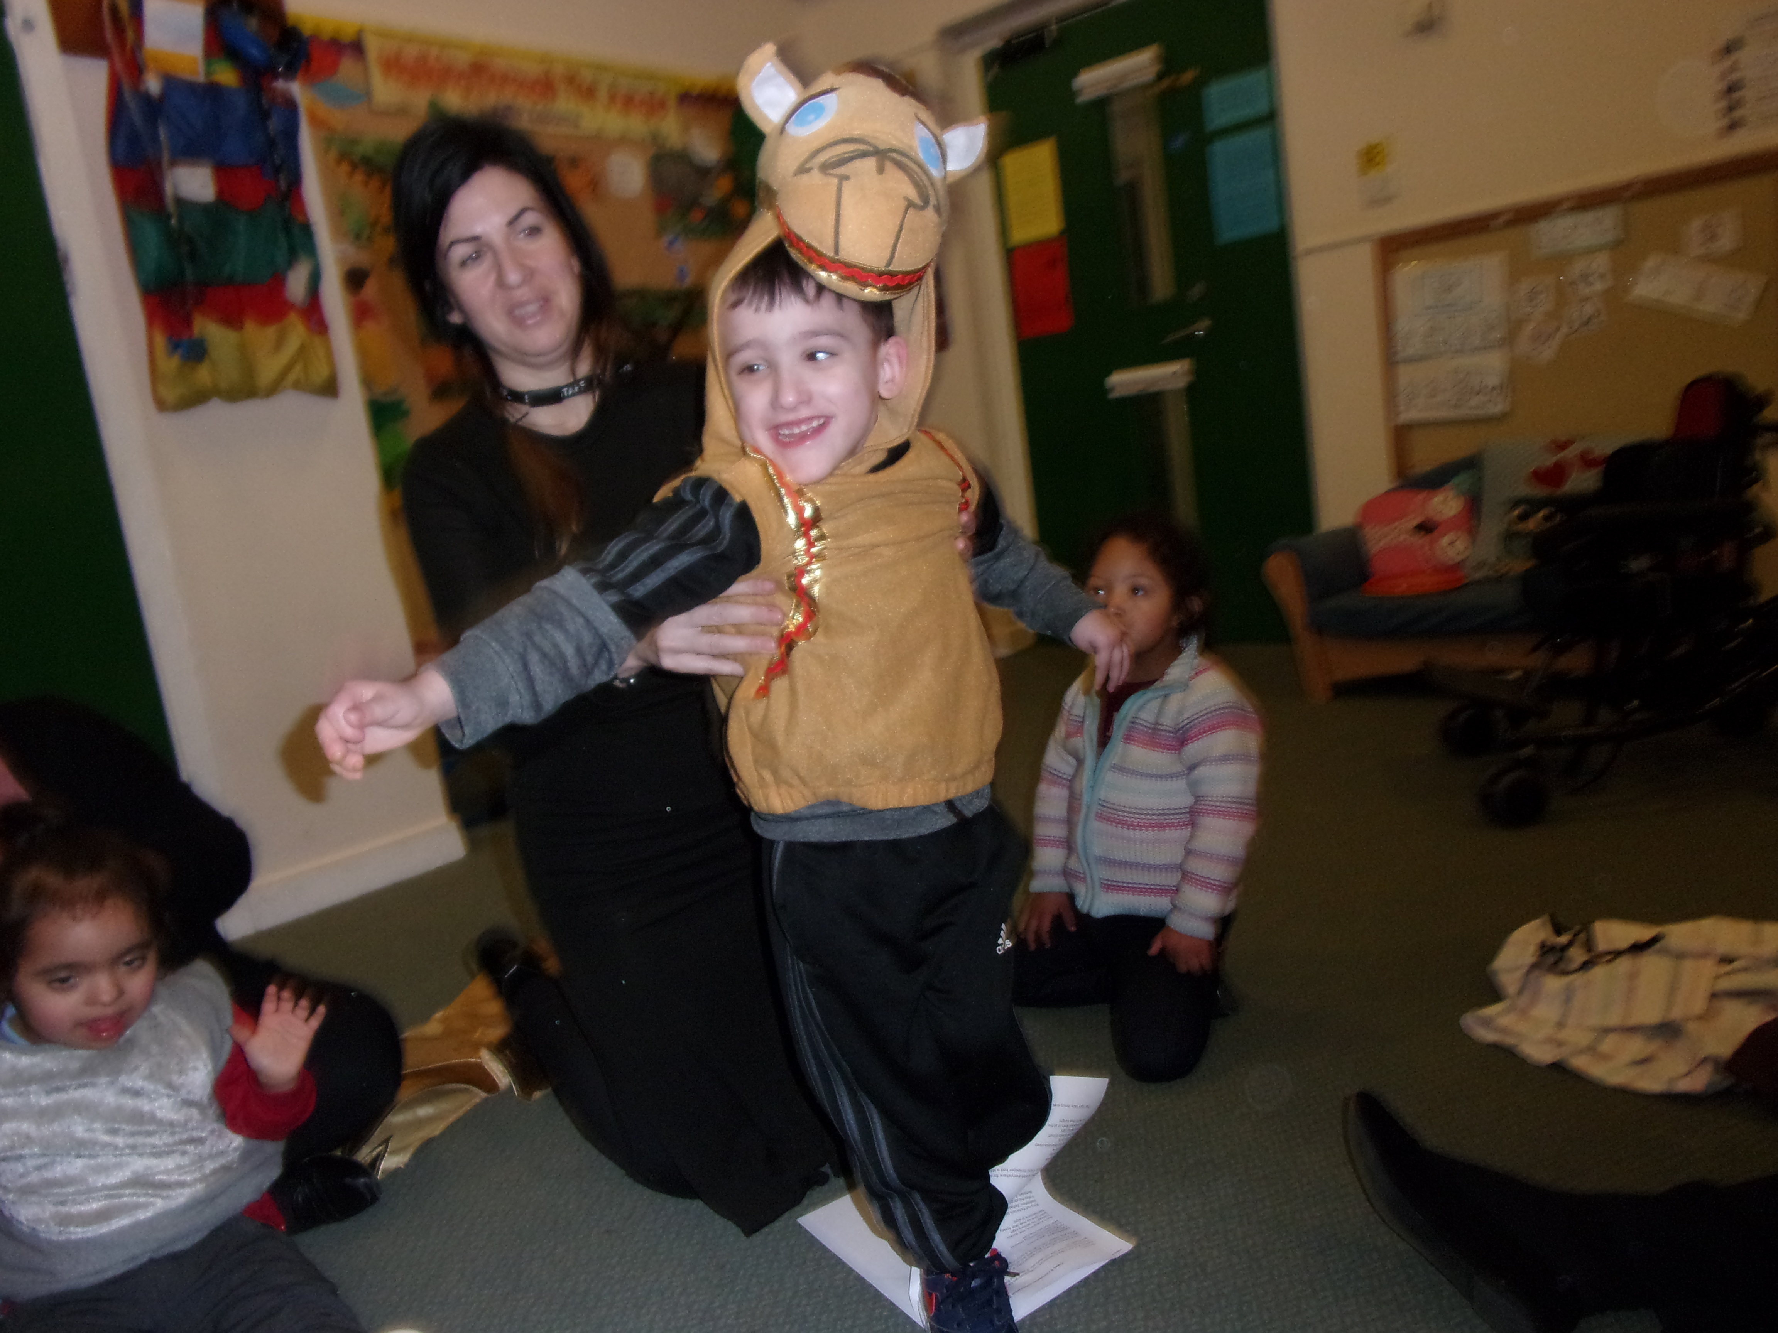

**Moon Room**

This term Star Class has been busy making lots of Christmas art. Some of our art will be displayed in the Hippodrome for the Pantomime.

If you’re going look at for our beautiful creations. Have a lovely Christmas and a Happy New Year.

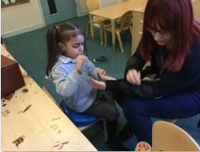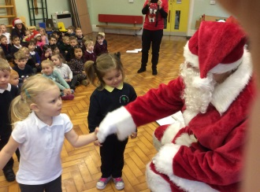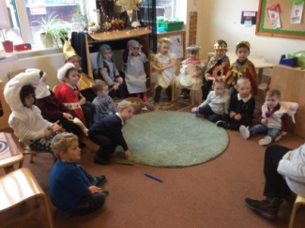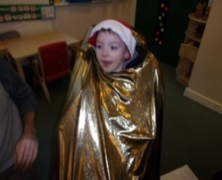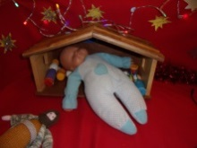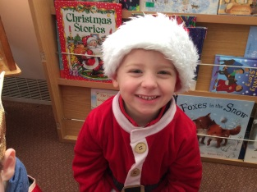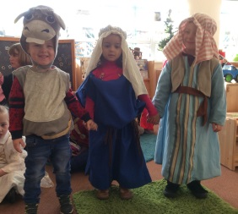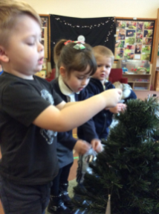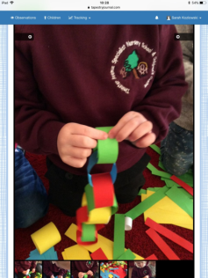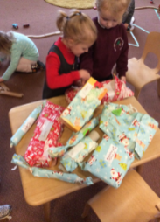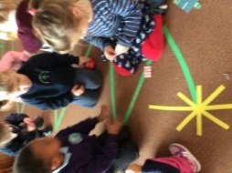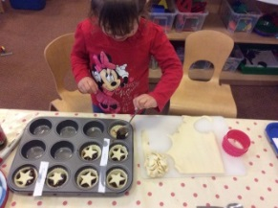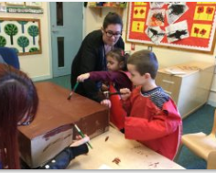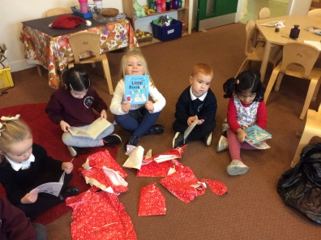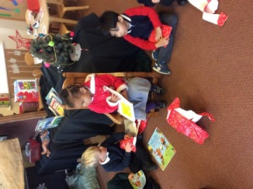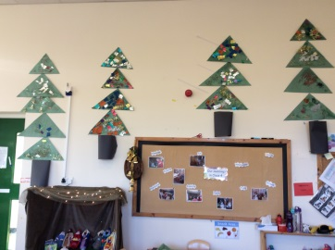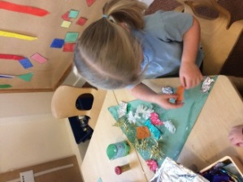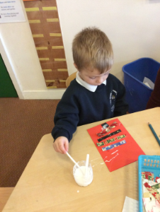

**Class 4**

Have had an amazing term we have had lots of fun exploring food, mark making, number hunts, and dressing up. We have learnt about the meaning of Christmas through the nativity, books and our own experiences. We would like to thank all of you for continued support and we would like to wish you all a Happy Christmas.

**Class 3**

Class 3 have been getting ready for Christmas by making mince pies, dressing up and saying hello to Father Christmas when he came to visit our nursery.  
Kind Regards  
Sandy Maynard  
(Class 3 Teacher)

**Class 1**

Father Christmas came to see us all in the hall on Monday and he gave each class a bag of presents to take back to their classroom. We were super pleased that he gave each of us a book. Thank you Santa!

We have been dressing up and telling the story of when Jesus was born in Bethlehem too.  
We have been learning lots of Christmas songs and playing the percussion instruments.  
 Merry Christmas everyone!

**Class 2**

In Class 2 we have been getting ready for Christmas. We have been exploring sprouts, making decorations, wrapping presents and decorating Christmas trees.  
Class 2 would like to wish everyone a Merry Christmas and a Happy New Year.