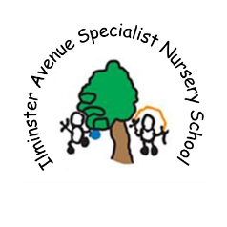

**Ilminster Avenue Specialist Nursery School**

**Newsletter**



February 2018

[](http://www.google.co.uk/url?sa=i&rct=j&q=&esrc=s&source=images&cd=&cad=rja&uact=8&ved=0ahUKEwimlczt6dDTAhXJtxoKHZgmBT8QjRwIBw&url=http://pngimg.com/img/nature/snowflakes&psig=AFQjCNGK44Od7wFcctcnAEiti_K_QHEV6w&ust=1493801357956926)

Hello Parents and Carers

What a busy term it has been. Lots of new children joining our setting; a warm welcome to you all.

Thank you all for your support when our boiler broke down, we did try to let as many people know as possible by text, Facebook and local radio. If you didn’t receive a text message, please check we have your correct number in the office.

Quick reminder it is half term next week so there will be no nursery all week. We come back on February 19th. We would also like to let you know that as soon as we get the letter from our last Ofsted visit we will share it with all of you, but we haven’t received it from them yet. We are hoping it will show all your parent views as well as how hard all the staff have been working on behalf of your amazing children! Matt & Trish.

**Snowflakes room**

Snowflakes have been very busy with food exploration we have explored dry lentils noodles baked beans coloured pasta and this week we have made toast and jam.

We are very sad to be saying goodbye to our friend Elizabeth and her family, we wish them well on their new journey.

We have also welcomed Fiona who has joined us from class 2 and our new friend who has joined us we hope they will be very happy in snowflakes.

[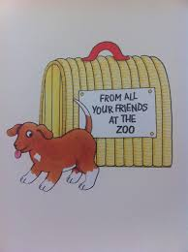](https://www.google.co.uk/imgres?imgurl=http://1.bp.blogspot.com/-z8BBMxQEp8M/UHWGrFiMAQI/AAAAAAAABBo/GSBq_S_fV5Q/s1600/photo.JPG&imgrefurl=http://www.culture-baby.net/2012/10/happy-birthday-dear-zoo.html&docid=zQeS9Efc9XnsVM&tbnid=1NdhewWuzf58_M:&vet=10ahUKEwjr08-oxI7ZAhXBsKQKHXoJBkA4ZBAzCEwoSjBK..i&w=1195&h=1600&safe=active&bih=673&biw=1024&q=dear%20zoo&ved=0ahUKEwjr08-oxI7ZAhXBsKQKHXoJBkA4ZBAzCEwoSjBK&iact=mrc&uact=8)[](https://www.google.co.uk/imgres?imgurl=https://i.gr-assets.com/images/S/compressed.photo.goodreads.com/books/1223633213i/972052._UY200_.jpg&imgrefurl=https://www.goodreads.com/book/show/809849.Dear_Zoo&docid=4fine8pKXGzRpM&tbnid=JQb5uuOI2ZPnpM:&vet=1&w=199&h=200&safe=active&bih=673&biw=1024&ved=0ahUKEwjcoNWG3YLZAhWGbxQKHUSiChcQxiAIFigB&iact=c&ictx=1)

[](http://www.google.co.uk/url?sa=i&rct=j&q=&esrc=s&source=images&cd=&cad=rja&uact=8&ved=0ahUKEwjF3MOP7tDTAhWQZFAKHaIjAgAQjRwIBw&url=http://clipart-library.com/tear-cliparts.html&psig=AFQjCNEpeOuF2eeFlkgYl41B4R97WLYtWQ&ust=1493802497420915)

**Raindrops Room**

We have had a busy term in Raindrops Room. We have had lots of new children join us and they have settled in really quickly and are confidently exploring their new environment. Please check outside the room for your children’s work as we have been doing lots of mark making this term.

We are sad to be saying goodbye to Marni this week. She has got a job as a Teaching Assistant in Fair Furlong Primary School, we wish her all the best.

We will be sending out a slip informing you of your child’s keyworker so you know who to contact when you have any concerns/questions.

Have a lovely half term

Marie, Louise, Marni, Hayley and Emily.

**Sun Room**Dear Zoo has been Sun Groups book at shared story time this term. The children have really engaged with the story and participated in lots of activities including; opening the flaps on the book to discover what is underneath, opening boxes to find animals, listening to animal sounds on switches and matching symbols to animals and writing a letter to ask for an animal they had chosen. Perhaps one of the best things that happened was during OFSTED; we had just got to the end of the story and opened the flap to see a dog when in walked Matt with his dog Jake, and the OFSTED inspector!! The children were so excited that suddenly there was a real dog there too. Unfortunately we could not keep him though!



[](http://www.google.co.uk/url?sa=i&rct=j&q=&esrc=s&source=images&cd=&cad=rja&uact=8&ved=0ahUKEwjF3MOP7tDTAhWQZFAKHaIjAgAQjRwIBw&url=http://clipart-library.com/tear-cliparts.html&psig=AFQjCNEpeOuF2eeFlkgYl41B4R97WLYtWQ&ust=1493802497420915)

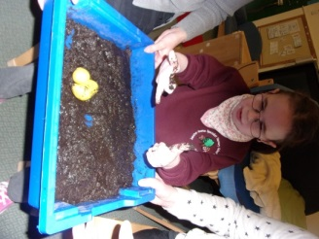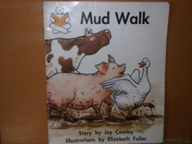

In science we have been exploring materials. We have explored lots of different materials around our school including natural and man-made.

**Moon Room**

'This Term for Literacy we've been having a Mud Walk! We painted and walked in mud, with our friends the Duck, the Pig and the Cow, and ... we got stuck! Luckily Ms Wishy-washy was on the ready to rescue us and give us a good wash. All of us got to play the different characters in the story and take part in first person'

**Star Room**

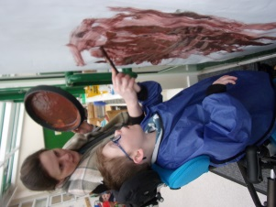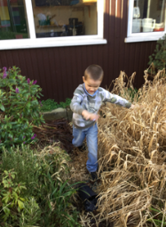

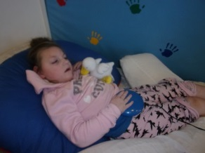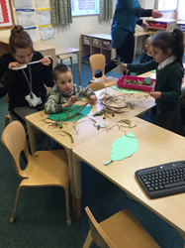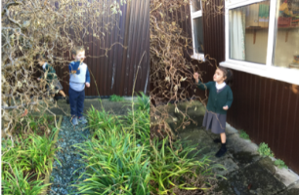

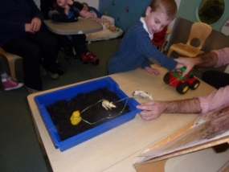

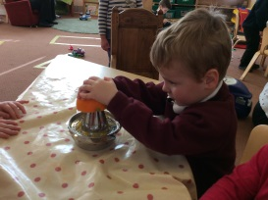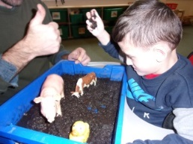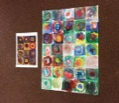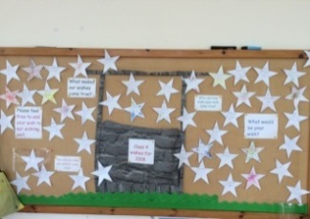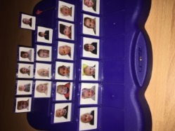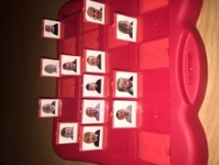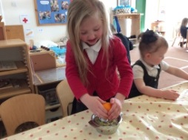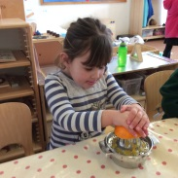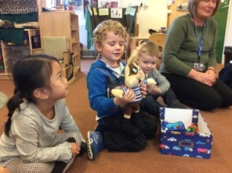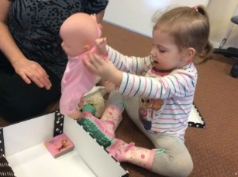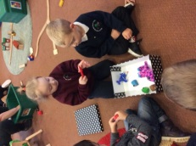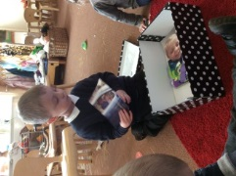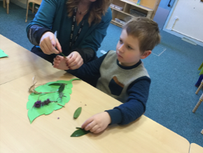  
  
  
  
  
  
  
  
  
  
  
  
  
  
  
  
  
  
  
  
  
  
  
  
  
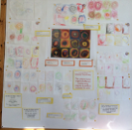

**Class 3**At snack time we had some satsumas to share.  When we cut them open there was a little bit of juice dripping out.  We asked the children to think about where we get orange Juice from? One child said "cows" another said "shops". We decided to investigate this further through hands on experience with oranges and a juicer.  The children pushed down hard, squeezed and twisted oranges.  They were excited to see the orange juice coming out and they liked drinking it.

**Class 2**

In Class 2 we have been practising our turn taking and listening skills and learning how we are the same and different to our friends.

Sarah made a “Class 2 Guess Who?” game.  
 We are looking forward to playing it with each other.

**Class 4  
What an amazing start to the New Year!**   
Parents and children have made their wishes in the wishing well, the children have done some fabulous art work inspired by Kandinsky as well as having lots of fun both indoors and in the garden.

We watched in awe out of the window the torrential rain the ever changing weather.  
Finally we love to share your children's achievement outside of school, so please fill out a wow slip and put in the wow box, are wow wall is looking rather bare.

**Class 1**

Class 1 have been busy sharing their Chatterboxes this term. The children have been fantastic at remembering to bring some precious favourite things from home to talk about with their friends. We have especially enjoyed seeing different photographs of holidays and pets.   
We still have lots of children who need to have their turn so don’t worry if you haven’t had a go yet.